**LAB # 02**



**DBMS LAB**

Submitted by: **Maaz Habib**

Registration No: **20PWCSE1952**

Class Section: **C**

“On my honor, as a student of University of Engineering and Technology, I have neither given nor received unauthorized assistance on this academic work.”

Submitted to:

**Engr. Sumayyea Salahuddin**

Wednesday, March 8th, 2023

**Department of Computer Systems Engineering**

**University of Engineering and Technology, Peshawar**

**Lab # 02: Static Web Design using HTML**

**OBJECTIVES OF THE LAB**

------------------------------------------------------------------------------------------------------------

This lab aims at the understanding of:

* *The basic syntax and structure of HTML.*
* *Identify the different types of headings and the appropriate usage for each.*
* *Understand how to create and use rules to style HTML elements.*
* *Learn how to use comments in HTML to provide additional information and context for the code.*
* *Understand how to structure paragraphs in HTML and use appropriate formatting tags.*
* *Understand how to use HTML styles to change the appearance of text and other elements.*
* *Learn how to create and format tables in HTML.*
* *Learn how to create and format lists in HTML.* • *Understand how to create and use forms to collect user input.*

# ---------------------------Task 2.2---------------------------

Forms play critical role in taking data to and from users. To enhance this ability, design three different types of forms using HTML Form. (Note: Don’t use CSS or Bootstrap. Only HTML.) Example forms can be registration form, contact form, student feedback form, etc.

**Registration form:**

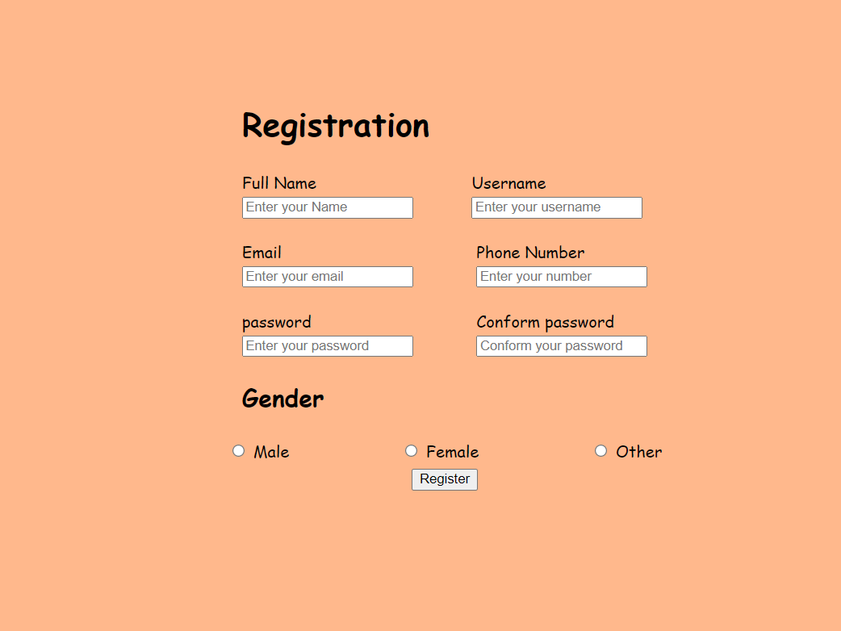

**Contact form:**

**Code:**

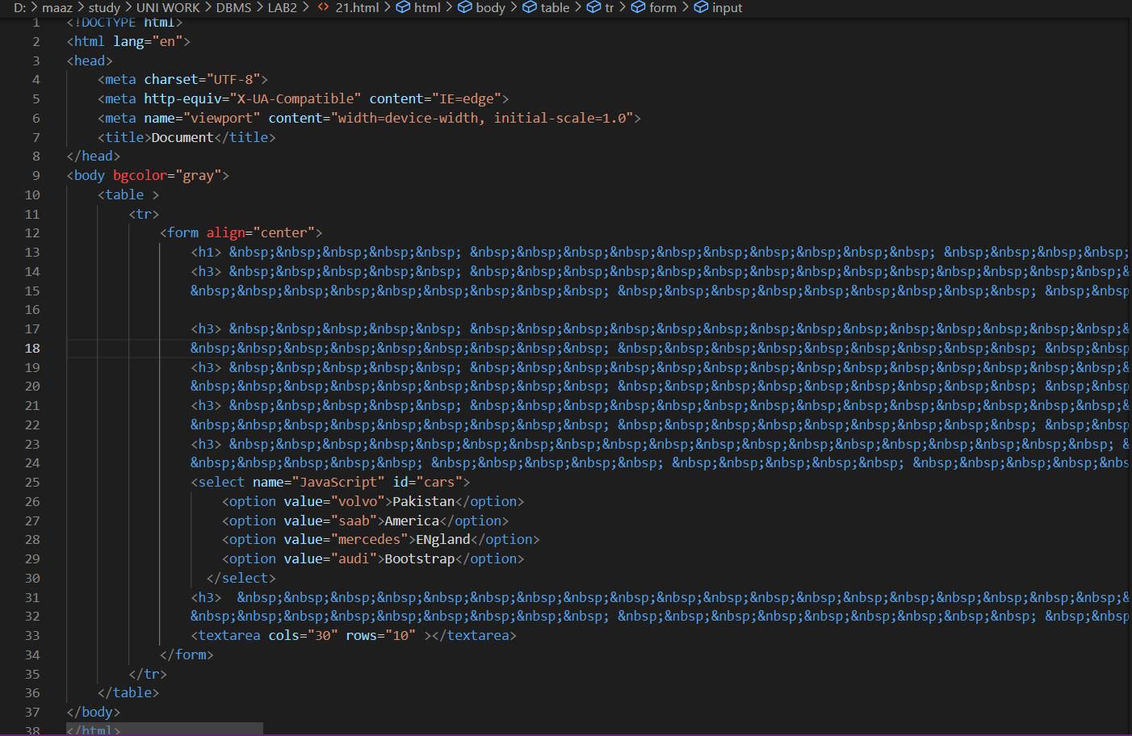

**Output:**

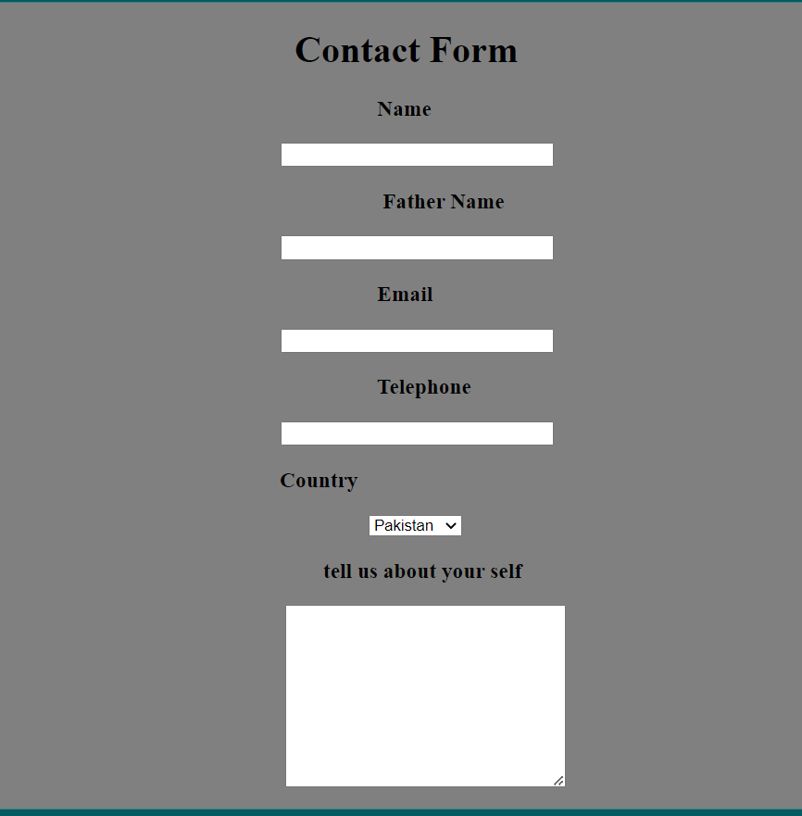

**Student feedback form:**

**Code:**

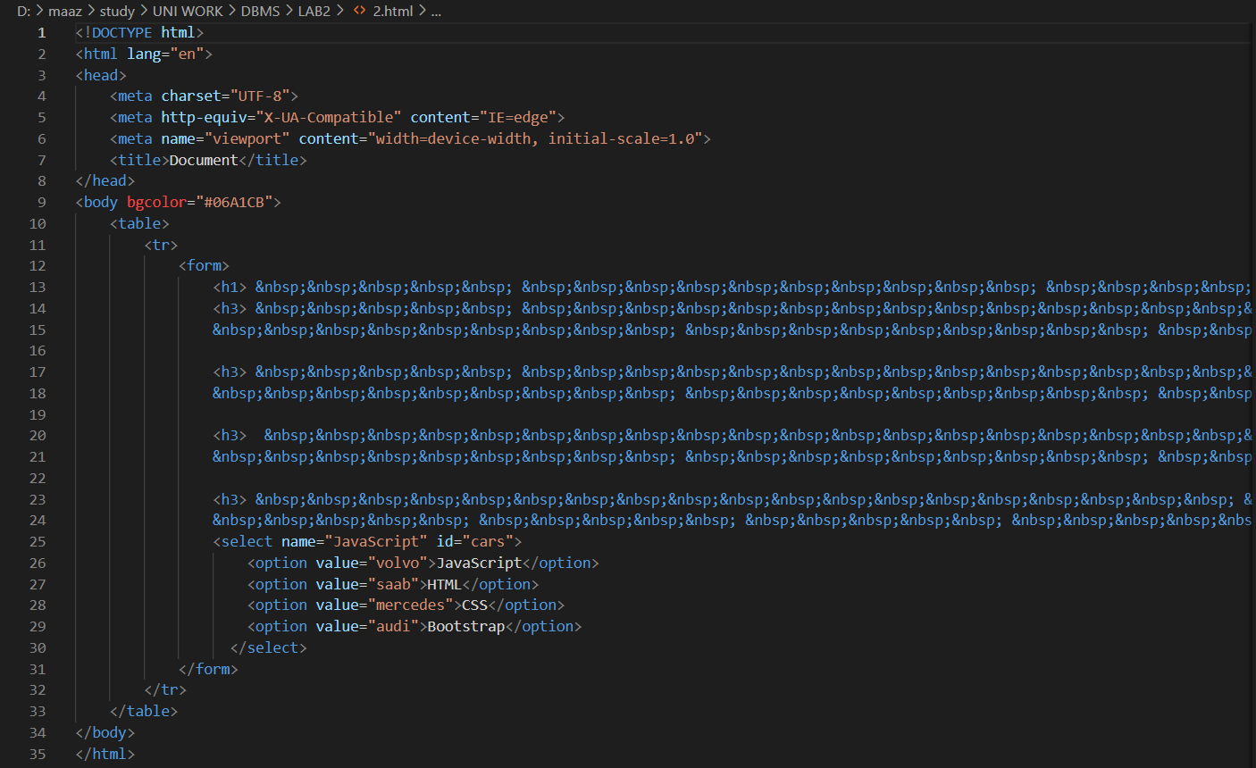

**Output:**

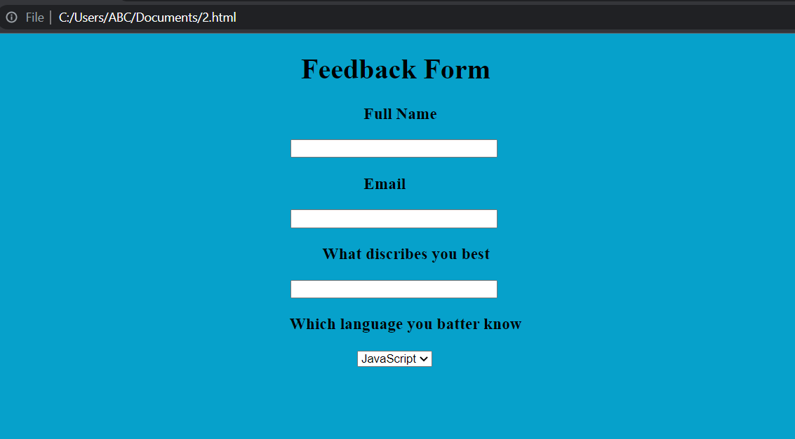

# ---------------------------Task 2.3---------------------------

Write the HTML code that generates the table given in Figure 2.16 (hint: use align attribute for cell alignment and set table width to 400 pixels):

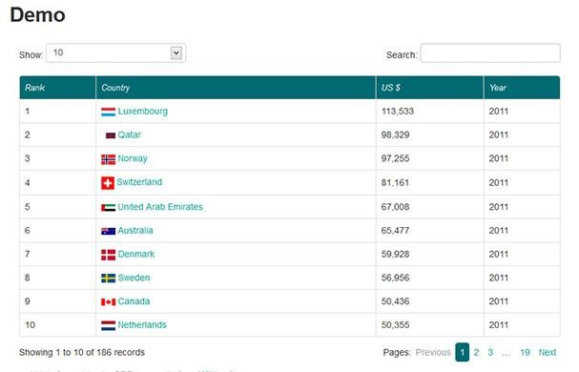

**Figure 2.16 – Task 2 output**

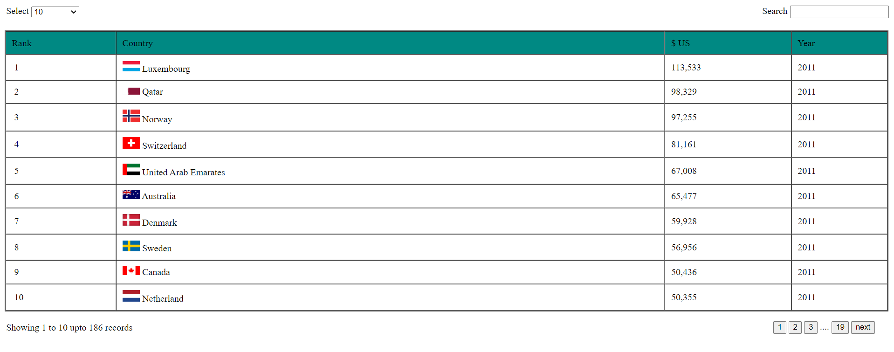

# ---------------------------Task 2.4---------------------------

There are many new features available in HTML 5. Pick at least five features that are not covered in this lab and introduce its usage through detailed examples and description. These features include figure, audio, video, svg, regular expressions, Geolocation, canvas, article, section, header, footer, drag & drop, form validation, and web sockets.

**Code:**

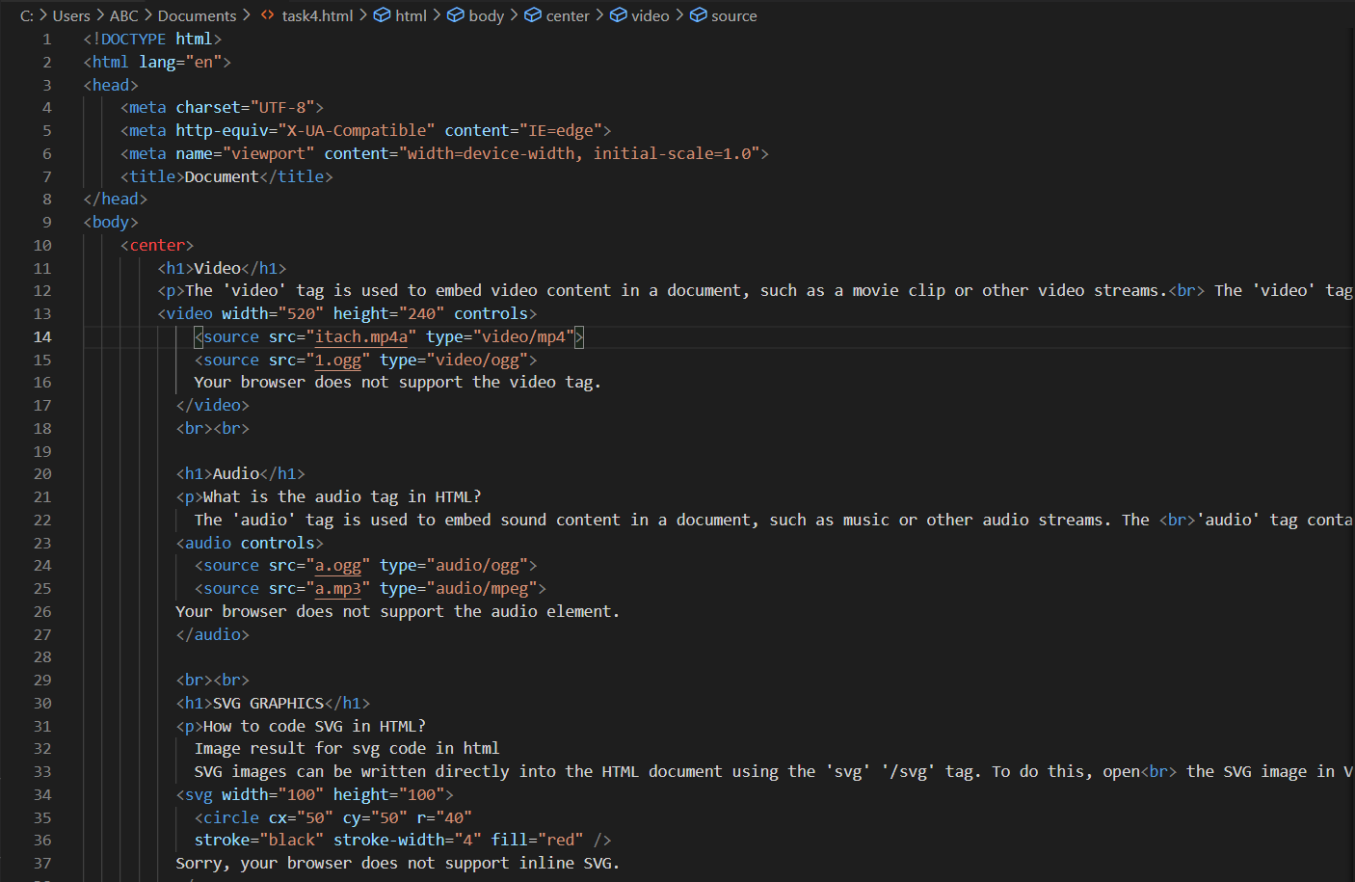

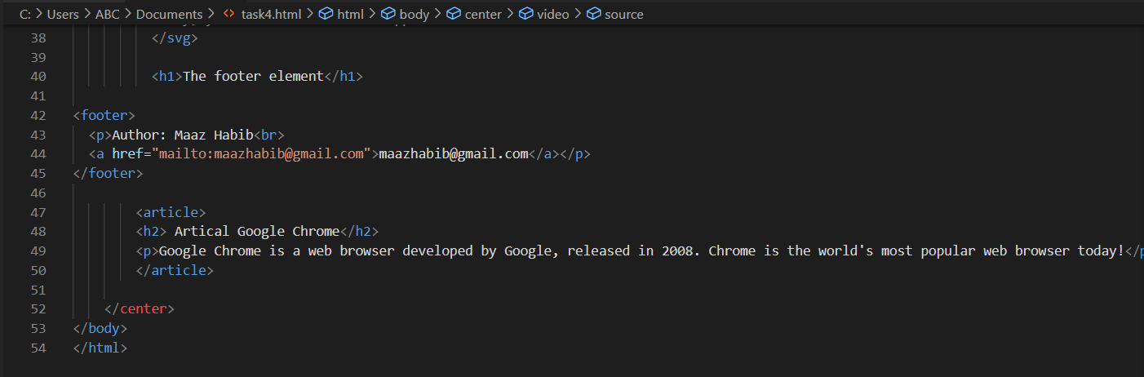

**Output:**

